Still remembering "Duck" is the first English word that I said to my daughter when she was 4 years old. Having doubt in English pronunciation of myself, concerning about how to illustrate enough and correctly for her to remember a word/phases. Hence, an idea for an image English tool was being born.

It takes 2 years of implementation, inclusive 1-year learning (as real & hard-working tester) by my daughter. Now, it’s time for publishing this web-application.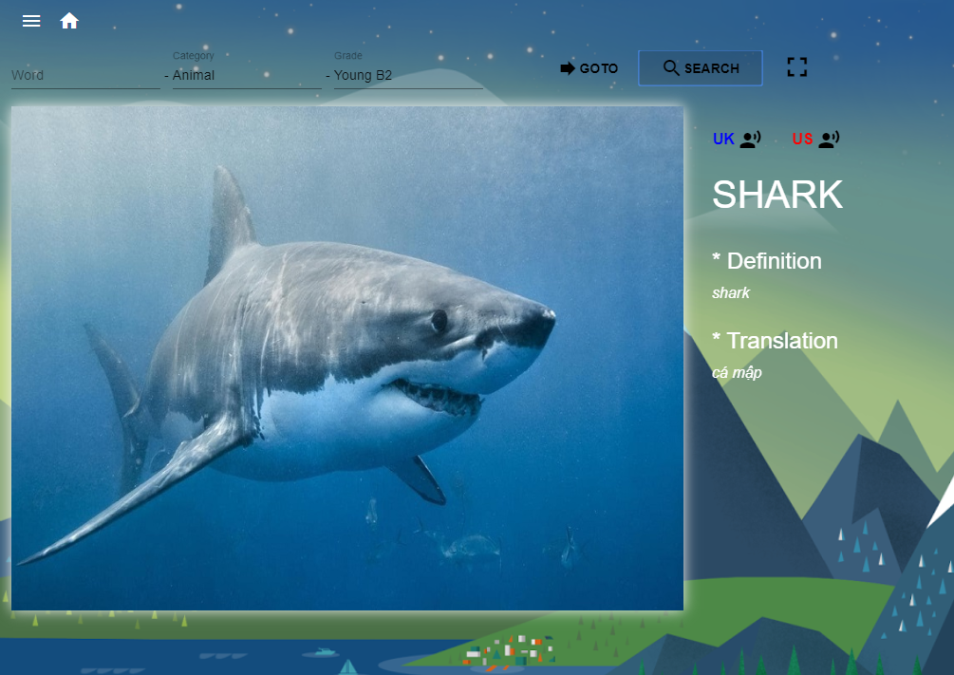

Beleive that **sohebox.com** will be one of the funniest ways to learn English by image and be familiar with both US & UK voice.

There are nearly 1000 words divided into 7 levels as of now for the user’s choice and being updated by times.

The application recommends users create their own accounts to manage learning progress also history and reportings. But you still can experience by using a **visitor** account first.